Business Requirements Document (BRD)

Project: Marketing Campaign Performance

Project Overview
The team needs a simple way to understand how different campaigns are performing across channels, audiences, and time periods. The objective is to build a dashboard that highlights key metrics such as impressions, clicks, conversions, spend and revenue. With data covering two years and a wide range of companies and customer segments, the dashboard should help identify what’s working, what’s not and where budgets can be optimized.

Business Objectives
Use the dataset to understand how campaigns are performing and what drives better results. The goal is to spot patterns in audience behavior, compare the effectiveness of different channels, and measure return on investment. These insights will help the team refine their marketing strategies, improve targeting, and make decisions that support stronger growth and better use of the marketing budget.

Data Source & Description
Key fields:
- Company: The company responsible for the campaign, representing a mix of fictional brands.
- Campaign_Type: The type of campaign employed, including email, social media, influencer, display, or search.
- Target_Audience: The specific audience segment targeted by the campaign, such as women aged 25-34, men aged 18-24, or all age groups.
- Duration: The duration of the campaign, expressed in days.
- Channels_Used: The channels utilized to promote the campaign, which may include email, social media platforms, YouTube, websites, or Google Ads.
- Conversion_Rate: The percentage of leads or impressions that converted into desired actions, indicating campaign effectiveness.
- Acquisition_Cost: The cost incurred by the company to acquire customers, presented in monetary format.
- ROI: Return on Investment, representing the profitability and success of the campaign.
- Location: The geographical location where the campaign was conducted, encompassing major cities like New York, Los Angeles, Chicago, Houston, or Miami.
- Language: The language used in the campaign communication, including English, Spanish, French, German, or Mandarin.
- Clicks: The number of clicks generated by the campaign, indicating user engagement.
- Impressions: The total number of times the campaign was displayed or viewed by the target audience.
- Engagement_Score: A score ranging from 1 to 10 that measures the level of engagement generated by the campaign.
- Customer_Segment: The specific customer segment or audience category that the campaign was tailored for, such as tech enthusiasts, fashionistas, health and wellness enthusiasts, foodies, or outdoor adventurers.
- Date: The date on which the campaign occurred, providing a chronological perspective to analyze trends and patterns.

Key Performance Indicators (KPIs)
- CPC = Cost Per Click ( Acquisition_Cost/ Clicks)
- Leads = Conversion_Rate * Impressions
- CPL = Cost Per Click ( Acquisition_Cost/ Leads)
- Total Clicks = Sum of clicks
- Average CPC = Total CPC ÷ Total CPC
- Average CPL = Total CPC ÷ Total CPC
- Average Conversion Rate = Average of Conversion rate

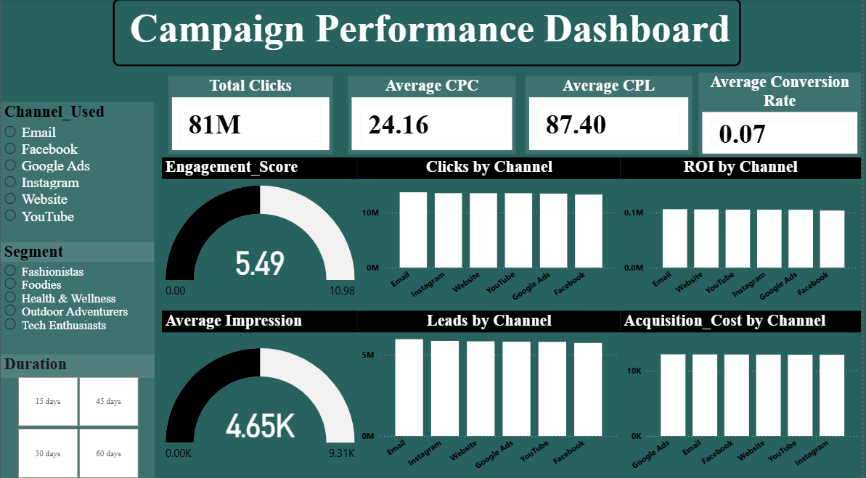
Analysis & Visualizations

Business Questions Answered
- Which audience segments respond best to our campaigns?
- Are our marketing channels aligned with the right audience?
- Where are we losing potential conversions?
- How can we improve overall conversion rates?
- What budget adjustments will drive better ROI?
- What creative and content strategy will maximize engagement?

Deliverables
- Analysis and Dashboard in Power BI.
- Visualizations (bar charts, line charts, trend charts).
- Business Requirements Document (BRD).
- Insights and recommendations for management.

Conclusion & Recommendations
The analysis provides a comprehensive view of Marketing Campaign Performance. Management can leverage these insights to:

Overall Campaign Insights
- Strong traffic volume but low conversion efficiency.
- High CPL highlights a weak funnel and poor conversion flow.
- ROI remains low due to high costs and poor conversion output.
- Engagement levels are moderate, suggesting room to improve content quality and relevance.
- Channel performance is stable, but no channel emerges as exceptionally profitable.
- Targeting, ad creatives, landing page flow, and segmentation need refinement to boost results.
- Low conversion rate combined with high CPL confirms that funnel optimization is urgently needed.

Target Group Insights
- Men 25–34 and Women 25–34 convert the best and show reliable performance across channels.
- Men 18–24 generate many clicks but deliver the lowest conversions, indicating weak intent or mismatched messaging.
- Younger audiences are less responsive to Email campaigns.
- Email performs best among the 25–34 demographic.

Channel Performance Insights
- Instagram, Google Ads, and Website consistently drive strong performance across most target groups.
- These channels deserve priority in budget allocation.
- Email works well for Tech Enthusiasts and Health & Wellness segments due to their preference for detailed content.
- Instagram is the strongest for lifestyle-focused groups like Fashionistas, Foodies, and Outdoor Adventurers.
- Facebook performs moderately but is not a top converter for any segment.
- Funnel inefficiencies affect all segments and channels, keeping costs high and conversions low.

Segment-Based Insights
- Tech Enthusiasts and Health & Wellness segments convert the strongest.
- These segments prefer informational, structured content delivered through Email and Google Ads.
- Lifestyle segments (Fashionistas, Foodies, Outdoor Adventurers) engage best with visual channels like Instagram.
- Conversion weaknesses across all segments point to issues with landing pages, targeting alignment, or offer relevance.

Recommendations
Lifestyle Segments (Fashion, Food, Outdoor)
Prioritize Instagram and Facebook
Use engaging visuals, reels, and creator-style content
Strengthen landing page visuals and storytelling
High-Intent Segments (Tech, Health & Wellness)
Increase focus on Google Ads and Email campaigns
Use long-form content, comparisons, and problem-solution messaging
Boosting Conversion Rate
Build dedicated landing pages for each segment
Add retargeting for high-click, low-lead audiences
Simplify forms and sharpen CTAs
Audience-Level Insights
Adjust creatives and messaging for Men 18–24 to improve intent
Allocate more budget to Instagram, Google Ads, and Website
Run A/B tests for CTAs and audience targeting
Create focused campaigns for Men 25–34 and Women 25–34
Add retargeting to improve conversions and reduce CPL

